
Robin Hood Primary Maths Root and Branch Curriculum Plan

Early Years Curriculum

Yr | Root Skills | Branch Learning  (Statutory Guidance as per DfE Curriculum 2014) | Leaf Learning (Specific Details of Learning)
1 | Number and place value | Count to and across 100, forwards and backwards, beginning with 0 or 1, or from any given number  Count, read and write numbers to 100 in numerals; count in multiples of twos, fives and tens  Given a number, identify one more and one less  Identify and represent numbers using objects and pictorial representations, including the number line, and use the language of: equal to, more than, less than, least, most  Read and write numbers from 1 to 20 in numerals and words | Number lines  count forwards from 80 to 110  count backwards from 105  Hundred square, number lines, groups of real objects, Numicon  Find p 39 in a book  Make a label to show how many things were in your collection  Count groups of 10 each of 2p, 5p and 10p coins  Hundred square, number lines  There are twenty nine beads in this pot. I am putting one more bead in the pot. How many are in there now? How did you know? How can you check?  This time there are forty beads in the pot. I take out one bead. How many beads are left in the pot? How did you know? How can you check?  Groups of real objects, Numicon, pictures, number lines  I’m giving each of you’re a strip of card with some numbers on (5 random from 0 to 30)  Point to the number which is worth most. Now point to the number which is worth least.  Make those numbers using tens and ones apparatus and put them in order  Make some labels for collections using numbers and words.
1 | Addition and subtraction | read, write and interpret mathematical statements involving addition (+), subtraction (–) and equals (=) signs  number bonds and related subtraction facts within 20  add and subtract one-digit and two-digit numbers to 20, including zero  solve one-step problems that involve addition and subtraction, using concrete objects and pictorial representations, and missing number problems such as 7 = ☐ – 9. | Language and symbols displayed in class, number lines, objects  Use the vocabulary add, subtract, minus, equals, is the same value as, total, more than, fewer/less than  Explain that things on both sides of the equals sign have the same value  Complete ‘empty box’ number sentences  Number lines, Numicon, rhymes, objects  I’m thinking of a number. I’ve subtracted 6 and the answer is 8. What number was I thinking of? Explain how you know  Number lines, Numicon, objects  What is 37 subtract 10? How did you work that out? How could you show that using cubes/a number line/a 100 square? What would 37 subtract 20 be?  Make up some different questions with the answer 5. Can you show how to solve them using counters?  Objects, number lines, hundred squares  Make up some additions with the answer 15. Try to put them in different ways, like this: 10 + 5 = 15. The total of 10 and 5 is 15. 10 and 5 more makes 15.
1 | Multiplication and division | solve one-step problems involving multiplication and division, by calculating the answer using concrete objects, pictorial representations and arrays with the support of the teacher. | Objects, arrays and images  Ben had 5 football stickers. His friend Tom gave him 5 more, how many does he have altogether?  Share 12 sweets between two children. How many do they each have?
1 | Fractions | recognise, find and name a half as one of two equal parts of an object, shape or quantity  recognise, find and name a quarter as one of four equal parts of an object, shape or quantity | Objects, images  Here is a set of 12 pencils  How many is half the set?  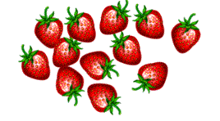  Four children hare 12 strawberries into equal parts.  How many strawberries will each child have?  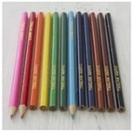
1 | Measure | compare, describe and solve practical problems for:  lengths and heights [for example, long/short, longer/shorter, tall/short, double/half]  mass/weight [for example, heavy/light, heavier than, lighter than]  capacity and volume [for example, full/empty, more than, less than, half, half full, quarter]  time [for example, quicker, slower, earlier, later]  measure and begin to record the following:  lengths and heights  mass/weight  capacity and volume  time (hours, minutes, seconds)  recognise and know the value of different denominations of coins and notes  sequence events in chronological order using language [for example, before and after, next, first, today, yesterday, tomorrow, morning, afternoon and evening]  recognise and use language relating to dates, including days of the week, weeks, months and years  tell the time to the hour and half past the hour and draw the hands on a clock face to show these times. | Rulers, measuring jugs, scales  Use their experience of standard units to make realistic estimates, answering questions such as:  Is the table taller or shorter than a metre?  Is this doll taller or shorter than one of the class rulers?  Does this bottle hold more or less than the litre jug?  Which of these things do you think will weigh less than a kilogram?  Rulers, measuring sticks, jugs, scales  Use standard units to measure and compare objects e.g. place metre sticks end to end to find out how much wider the hall is than the classroom  Money, games  They use coins to help them to respond to questions such as:  Michael had £5. He spent £3. How much did he have left?  Rosie had a 10p coin. She spent 3p. How much change did she get?  How much altogether is 1p and 2p and 5p?  They use terms such as morning, afternoon and evening, yesterday and tomorrow.  They learn to order the days of the week and learn that weekend days are Saturday and Sunday  They listen to stories and rhymes about time, such as The Very Hungry Caterpillar or The Bad-Tempered Ladybird  Order the months of the year and make a 12 page classroom calendar with pictures of each month, writing significant events underneath, such as Divali etc  Clocks, time lines  Read time to the hour and half hour on a clock with hands and recognise half past the hour in day to day routines  Its half past seven. What time will it be in four hours time? What time was it 2 hours ago?
1 | Geometry-properties of shape | recognise and name common 2-D and 3-D shapes, including:  2-D shapes [for example, rectangles (including squares), circles and triangles]  3-D shapes [for example, cuboids (including cubes), pyramids and spheres]. | Give each child a shape. Look at the shape I have given you. Tell me one thing about the shape.  Give each child 2 shapes. Tell me something that is the same about the two shapes.  Now tell me something that is different about the two shapes.
1 | Geometry- position and direction | describe position, direction and movement, including whole, half, quarter and three-quarter turns. | Look at the map. Go to start.  Follow this route from there.  Go to the fourth house on the right.  Draw a ring around it  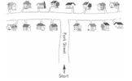
2 | Number and place value | Count in steps of 2, 3 and 5 from 0 and in tens from any number, forwards and backwards  Recognise the place value of each digit in a 2 digit number (tens, ones)  Identify, represent and estimate numbers using different representations, including the number line  Compare and order numbers from 0 up to 100; use < > and = signs  Read and write numbers to at least 100 in numerals and in words  Use place value and number facts to solve problems | use their knowledge of counting on from or back from zero in steps of 2, 3, 5 and 10 to answer multiplication and division questions such as 7 x 2 and 40 ÷ 5  Look at these numbers.  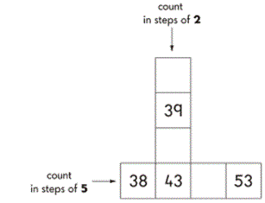  37 12 45 60 72 27  Which of these numbers in the largest?  Which of these numbers is between 10 and 20  Children should be able to represent numbers using equipment such as bundles of ten and single art straws, 10p and 1p coins and number lines  Look at the squares of chocolate  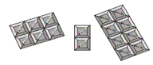  There are 16 squares  Tick the sum that matches the picture  5 + 2 + 9 = 16  5 + 6 + 5 = 16  6 + 6 + 4 = 16  6 + 2 + 8 = 16  8 + 3 + 5 = 16  Here are 2 signs < >  Use these signs to make these correct  52 __ 17  18 __ 91  What numbers can you make using two of these digits: 3, 6, 0?  Write down each number you make. Read those numbers to me. Can you write the largest of the numbers in words
2 | Addition and subtraction | solve problems with addition and subtraction:  using concrete objects and pictorial representations, including those involving numbers, quantities and measures  applying their increasing knowledge of mental and written methods  recall and use addition and subtraction facts to 20 fluently, and derive and use related facts up to 100  add and subtract numbers using concrete objects, pictorial representations, and mentally, including: a two-digit number and ones  a two-digit number and tens  two two-digit numbers  adding three one-digit numbers  show that addition of two numbers can be done in any order (commutative) and subtraction of one number from another cannot  recognise and use the inverse relationship between addition and subtraction and use this to check calculations and solve missing number problems. | Use partitioning, counting strategies and knowledge of number bonds to add or subtract a one digit number or a multiple of 10 to any two digit number. To work out 86 – 50  86 – 50 = 80 + 6 – 50 = 80 – 50 + 6 = 30 + 6 = 36  Children add or subtract 2 digit numbers using practical and informal methods.  They count back along a number line to find 64 – 25 or count up from 67 to find the answer to 94 – 67. They represent these as number sentences.  They calculate the value of an unknown in a number sentence such as __ ÷ 2 = 6  Use partitioning and number bonds to add and subtract numbers mentally to answer questions such as 60 - __ = 52 or 35 = 20 + __  Look at this number: __ + __ = 20. What could the two missing numbers be? What else?  Can you tell me all the pairs of numbers that make 20?  Understand that addition can be done in any order and use this to solve an addition by rearranging the numbers. They need to understand that two numbers can be taken away from each other but the answers will not be the same.  Check their addition and subtraction with a calculation that uses the inverse operation.  Look at this number sentence: 74 – 13 = 61  Write 3 more number sentences using these numbers. How do you know, without calculating, that they are correct?  I think of a number. I subtract 19 and the answer is 30. What is my number? How do you know?
2 | Multiplication and division | recall and use multiplication and division facts for the 2, 5 and 10 multiplication tables, including recognising odd and even numbers  calculate mathematical statements for multiplication and division within the multiplication tables and write them using the multiplication (×), division (÷) and equals (=) signs  show that multiplication of two numbers can be done in any order (commutative) and division of one number by another cannot  solve problems involving multiplication and division, using materials, arrays, repeated addition, mental methods, and multiplication and division facts, including problems in contexts | Recognise a multiple of 2, 5 or 10 and use their knowledge of multiplication facts to find division facts. They can say which numbers are odd and which are even.  2 x 5 = 10, show me 3 more number facts using these numbers.  Is 34 an odd number? How do you know?  Find missing numbers in calculations  4 x _ = 20  _ ÷ 10 = 3  Anna has 3 boxes of cakes. Each box contains 5 cakes. How many cakes does she have altogether? Show how you worked it out  Children should use their knowledge of triangles of numbers to show related number facts  If 6 x 2 = 12 then 2 x 6 = 12 and 12 ÷ 6 = 2  Use various methods and apparatus to help them solve word problems such as:  There are 10 lollies in a bag. Charlie needs 30 lollies for his party. How many bags does he need to buy? Show me how you worked this out
2 | Fractions | recognise, find, name and write fractions ⅓, ¼, ²⁄₄ and ¾ of a length, shape, set of objects or quantity  write simple fractions e.g. ½ of 6 = 3 and recognise the equivalence of two quarters and one half. | Harrison and Sam were talking and Harrison said that if he doubled Sam’s age and added 2 he would get 12  Would a chocolate lover rather have ½ or 3/5 of this bar of chocolate? Explain your answer
2 | Measure | choose and use appropriate standard units to estimate and measure length/height in any direction (m/cm); mass (kg/g); temperature (°C); capacity (litres/ml) to the nearest appropriate unit, using rulers, scales, thermometers and measuring vessels  compare and order lengths, mass, volume/capacity and record the results using >, < and =  recognise and use symbols for pounds (£) and pence (p); combine amounts to make a particular value  find different combinations of coins that equal the same amounts of money  solve simple problems in a practical context involving addition and subtraction of money of the same unit, including giving change  compare and sequence intervals of time  tell and write the time to five minutes, including quarter past/to the hour and draw the hands on a clock face to show these times  know the number of minutes in an hour and the number of hours in a day. | Suggest sensible units you might use to measure: the height of your table, how much water is in a cup.  Choose a piece of equipment to help you measure: the weight of your shoe, how long the classroom is  How long is this line? Now draw a line 2cm longer than this one.  Find an object in the classroom that you think is about 10cm long.  About how heavy do you think your encil case is?  Megan and Jack are growing beans. Megan’s plant is 25cm tall. Jack’s is 38cm tall. Whose plant is taller? By how much? Can you compare them using < or >?  Holly has these coins.  Harry has the same amount of money but has six coins. What are they? Is there only one possible answer?  Jess has saved 62p. She spends 15p. How much money does she have left? She pays with a 50p piece. How much change does she get?  What time does this clock show?  Draw a clock showing the time five minutes later.  Show your school day on clock faces: when do you leave home, have breaks, go home etc?
2 | Geometry- properties of shape | identify and describe the properties of 2-D shapes, including the number of sides and line symmetry in a vertical line  identify and describe the properties of 3-D shapes, including the number of edges, vertices and faces  identify 2-D shapes on the surface of 3-D shapes, [for example, a circle on a cylinder and a triangle on a pyramid]  compare and sort common 2-D and 3-D shapes and everyday objects. | 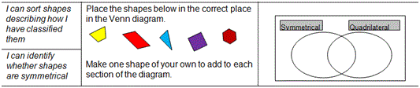  Children can sort two sets of 2D and 3D shapes in 2 or more different ways using different criteria each time.
2 | Geometry- position and direction | order and arrange combinations of mathematical objects in patterns and sequences  use mathematical vocabulary to describe position, direction and movement, including movement in a straight line and distinguishing between rotation as a turn and in terms of right angles for quarter, half and three-quarter turns (clockwise and anti-clockwise) | Describe the patterns in sequences and predict what comes next in the sequence and continue the pattern.  Recognise whole, half and quarter turns. They describe turns and gve and follow instructions to turn. They make and draw half and quarter turns from the same starting point using, for example, two geostrips
2 | Statistics | interpret and construct simple pictograms, tally charts, block diagrams and simple tables  ask and answer simple questions by counting the number of objects in each category and sorting the categories by quantity  ask and answer questions about totalling and comparing categorical data. | Class 2 make a graph  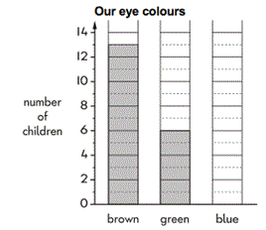  5 children have blue eyes. Show this on the graph. More children have brown eyes than green eyes.  How many more?  Look at this pictogram  GRAPH  There are 12 boys in class 5.  Show this on the pictolgram.  A shop sold 10 ice lollies on Wednesday  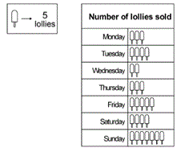  How many lollies were sold on Monday?  Some children rolled toy cars down a slope  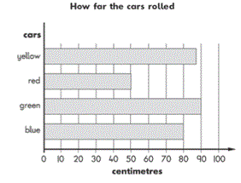  How far did the blue car roll?  How much further did the green car roll than the red car?
3 | Number and place value | count from 0 in multiples of 4, 8, 50 and 100; find 10 or 100 more or less than a given number  recognise the place value of each digit in a three-digit number (hundreds, tens, ones)  compare and order numbers up to 1000  identify, represent and estimate numbers using different representations  read and write numbers up to 1000 in numerals and in words  solve number problems and practical problems involving these ideas. | Count on from zero in steps of 2, 2, 4, 5, 8, 50, 100.  For each of these numbers: 428, 205, 130, 25, 7, 909. Tell me: How many hundreds? How many tens? How many ones?  Sort these numbers into ascending order: 95, 163, 8, 740, 25, 0, 400, 303  Show me 642 on a number line.  What number is halfway between 65 and 95? How do you know?  Read these numbers: 438, 205, 130, 25, 7, 909  Jack walks 645 metres to school. Suzy walks 100 metres less. How far does Suzy walk?  What is 1 more than 485? Than 569? Than 299?
3 | Addition and subtraction | add and subtract numbers mentally, including:  a three-digit number and ones  a three-digit number and tens  a three-digit number and hundreds  add and subtract numbers with up to three digits, using formal written methods of columnar addition and subtraction  estimate the answer to a calculation and use inverse operations to check answers  solve problems, including missing number problems, using number facts, place value, and more complex addition and subtraction. | See school calculation policy  Paul says 172 – 15 = 163. Write down an addition calculation that you could do to check this.  Work out the missing digits:  3_ + _ 2 = 85  Layla has 45p in her money bank and 28p in her purse. How much more money does she need to buy a comic that costs £1?  What is the difference between 1999 and 4003?
3 | Multiplication and division | recall and use multiplication and division facts for the 3, 4 and 8 multiplication tables  write and calculate mathematical statements for multiplication and division using the multiplication tables that they know, including for two-digit numbers times one-digit numbers, using mental and progressing to formal written methods  solve problems, including missing number problems, involving multiplication and division, including positive integer scaling problems and correspondence problems in which n objects are connected to m objects. | Leila puts 4 seeds in each of her pots. She uses 6 pots and has I seed left over. How many seeds did she start with?  One orange costs 19p. How much will three oranges cost?  Miss West needs 28 paper cups. She has to buy them in packs of 6. How many packs does she have to buy?
3 | Fractions | count up and down in tenths; recognise that tenths arise from dividing an object into 10 equal parts and in dividing one-digit numbers or quantities by 10  recognise, find and write fractions of a discrete set of objects: unit fractions and non-unit fractions with small denominators  recognise and use fractions as numbers: unit fractions and non-unit fractions with small denominators  recognise and show, using diagrams, equivalent fractions with small denominators  add and subtract fractions with the same denominator within one whole [for example, ⁵⁄₇ + ¹⁄₇ = ⁶⁄₇ ]  compare and order unit fractions with the same denominator  solve problems that involve all of the above. | Divide single digits or whole number by 10  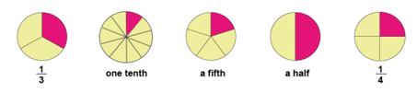  A fraction of each shape is shaded. Match each fraction to the correct place on the number line. One has been done for you.  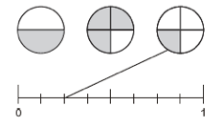  Children should be able to:  - identify pairs of fractions that total 1.  - Circle 2 fractions that have the same value.  Would you rather have 1/3 of 30 sweets or 1/5 of 40 sweets? Why?  15 grapes are shared equally onto 5 plates. What fraction of the grapes is on each plate?
3 | Measure | measure, compare, add and subtract: lengths (m/cm/mm); mass (kg/g); volume/capacity (l/ml)  measure the perimeter of simple 2-D shapes  add and subtract amounts of money to give change, using both £ and p in practical contexts  tell and write the time from an analogue clock, including using Roman numerals from I to XII, and 12-hour and 24-hour clocks  estimate and read time with increasing accuracy to the nearest minute; record and compare time in terms of seconds, minutes and hours; use vocabulary such as o’clock, a.m./p.m., morning, afternoon, noon and midnight  know the number of seconds in a minute and the number of days in each month, year and leap year  compare durations of events [for example to calculate the time taken by particular events or tasks]. | Show something that they think is just shorter/longer than a m/cm/mm  Which object in the classroom is heavier than 100g?  Measure the sides of regualr polygons in cm and mm and find their perimetres in cm and mm  Jake wants to buy a comic that costs £1. He saves 25p one week and 40p the next.  Children should be able to times on analogue and digital formats (including Roman Numerals)  Ben’s clock says 7:50 when he gets up. Place the hands on a clock to show the time.  Kevin leaves home at quarter past 8 and arrives in scholl at 20 to 9. How long is his journey? How did you work this out?  Milly uses a stop-watch to time her cat eating its breakfast one morning. The reading on the stop-watch, once the cat has finished eating, says 135 seconds. Can you convert this into minutes and seconds?  It takes 35 minutes to walk from home to school. I need to be there at 8:55am. What time do I need to leave home?
3 | Geometry- properties of shape | draw 2-D shapes and make 3-D shapes using modelling materials; recognise 3-D shapes in different orientations and describe them  recognise angles as a property of shape or a description of a turn  identify right angles, recognise that two right angles make a half-turn, three make three quarters of a turn and four a complete turn; identify whether angles are greater than or less than a right angle  identify horizontal and vertical lines and pairs of perpendicular and parallel lines. | Use appropriate mathematical vocabulary to describe the features of common 2D and 3D shapes  Record classifications of shapes on Venn and Carroll diagrams
3 | Statistics | interpret and present data using bar charts, pictograms and tables  solve one-step and two-step questions [for example, ‘How many more?’ and ‘How many fewer?’] using information presented in scaled bar charts and pictograms and tables. | Children sort and classify objects, numbers or shapes according to 2 criteria, and display this on Venn and Carroll diagrams
4 | Number and place value | count in multiples of 6, 7, 9, 25 and 1000  find 1000 more or less than a given number  count backwards through zero to include negative numbers  recognise the place value of each digit in a four-digit number (thousands, hundreds, tens, and ones)  order and compare numbers beyond 1000  identify, represent and estimate numbers using different representations  round any number to the nearest 10, 100 or 1000  solve number and practical problems that involve all of the above and with increasingly large positive numbers  read Roman numerals to 100 (I to C) and know that over time, the numeral system changed to include the concept of zero and place value. | Know that 9 x 8 = 72 so that 72 ÷ 9 = 8 and deduce 720 ÷ 9  What is the missing number in the number sentence and how do you know? 5742 + ___ = 9742  What number can you put in the box to make this statement true? __ < -2  Recognise a number partitioned like this: 4000 + 200 + 60 + 3 and be able to read and write the number  Find the numbers that could go in the boxes to make these correct, ____ < 2000, 3000 > ___  Which of these numbers is closest to the answer of 342 – 119: 220, 220, 230, 250, 300  I rounded a number to the nearest 10. The answer is 340. What number could I have started with?  There are 70 children. Each tent can accommodate up to 6 children. What is the smallest number of tents they will need?  Know what each letter represents in Roman numerals and be able to convert from Roman numerals to our current system
4 | Addition and subtraction | add and subtract numbers with up to 4 digits using the formal written methods of columnar addition and subtraction where appropriate  estimate and use inverse operations to check answers to a calculation  solve addition and subtraction two-step problems in contexts, deciding which operations and methods to use and why. | See calculation policy  Tina has read the first 85 pages in a book that is 150 pages long. Which number sentence could Tina use to find the number of pages she must read to finish the book?  - 150 + 85 = ___  - ___ - 85 = 150  - 150 ÷ 85 = __  - 150 – 85 = __  I have read 134 of the 512 pages of my book. How many more pages must I read to reach the middle?  I have a number, subtract 17, and divide by 6. The answer is 20. What was my number?
4 | Multiplication and division | recall multiplication and division facts for multiplication tables up to 12 × 12  use place value, known and derived facts to multiply and divide mentally, including: multiplying by 0 and 1; dividing by 1; multiplying together three numbers  recognise and use factor pairs and commutativity in mental calculations  multiply two-digit and three-digit numbers by a one-digit number using formal written layout  solve problems involving multiplying and adding, including using the distributive law to multiply two digit numbers by one digit, integer scaling problems and harder correspondence problems such as n objects are connected to m objects | What is twenty one multipled by nine?  How many twos are there in four hundred and forty?  Divide thirty-one point five by ten.  Ten times a number is eighty-six. What is the number?  Know 8 x 15 is the same as 15 x 8  See calculation policy  185 people go to the school concert. They pay £1.35 each. How much ticket money is collected?  Programmes cost 15p each. Selling programmes raises £12.30. How many programmes are sold?
4 | Fractions | recognise and show, using diagrams, families of common equivalent fractions  count up and down in hundredths; recognise that hundredths arise when dividing an object by one hundred and dividing tenths by ten.  solve problems involving increasingly harder fractions to calculate quantities, and fractions to divide quantities, including non-unit fractions where the answer is a whole number  add and subtract fractions with the same denominator  recognise and write decimal equivalents of any number of tenths or hundredths  recognise and write decimal equivalents to ¼, ½, ¾  find the effect of dividing a one- or two-digit number by 10 and 100, identifying the value of the digits in the answer as ones, tenths and hundredths  round decimals with one decimal place to the nearest whole number  compare numbers with the same number of decimal places up to two decimal places  solve simple measure and money problems involving fractions and decimals to two decimal places. | What does the digit 6 in 3.64 represent? What is the 4 worth in the number 7.45?  Continue the count: 1.91, 1,92, 1.93, 1.94  ¼ + ¾  Which of these decimals is equal to 19/100? 1.9, 10.19, 0.19, 19.1  Write each of these as a decimal fraction: 27/100, 3/100  How many times larger is 2600 than 26?  How many £1 notes are in £120, £1200?  Round these to the nearest whole number: 9.7, 25.6, 148.3  Which is lighter: 3.5kg or 5.5kg?  Put in order from largest: 6.2, 5.7, 4.5, 7.6, 5.2, 1.99, 1.2, 2.1  A box of 4 balls costs £2.96. How much does each ball cost? Dean and Alex buy 3 boxes of balls between them. Dean pays £4.50. How much must Alex pay?  Harry spent ¼ of his savings on a book. What did the book cost if he saved; £8, £10, £2.40
4 | Measure | Convert between different units of measure [for example, kilometre to metre; hour to minute]  measure and calculate the perimeter of a rectilinear figure (including squares) in centimetres and metres  find the area of rectilinear shapes by counting squares  estimate, compare and calculate different measures, including money in pounds and pence  read, write and convert time between analogue and digital 12- and 24-hour clocks  solve problems involving converting from hours to minutes; minutes to seconds; years to months; weeks to days. | They learn that kilo means one thousand to help them remember that there are 1000 grams in 1 kilogram and 1000 metres in 1 kilometre. They respond to questions such as: A bag of flour weighs 2 kg. How many grams is this?  Draw irregular shapes on cm squared paper grids, and compare their areas and perimeters  Dad bought three tins of paint at £5.68 each. How much change does he get from £20?  I spent £4.63, £3.72 and 86p. How much did I spend altogether?  Raiza got into the pool at 2:26pm. She swan until 3 o’clock. How long did she swim?
4 | Geometry- properties of shape | compare and classify geometric shapes, including quadrilaterals and triangles, based on their properties and sizes  identify acute and obtuse angles and compare and order angles up to two right angles by size  identify lines of symmetry in 2-D shapes presented in different orientations  complete a simple symmetric figure with respect to a specific line of symmetry. | All equilateral triangles have…  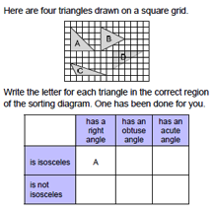  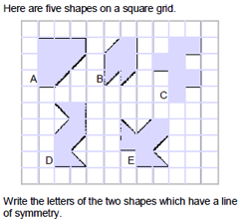  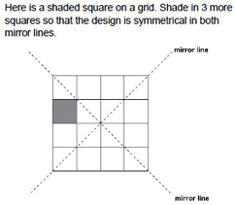
4 | Geometry- position and direction | describe positions on a 2-D grid as coordinates in the first quadrant  describe movements between positions as translations of a given unit to the left/right and up/down  plot specified points and draw sides to complete a given polygon. | 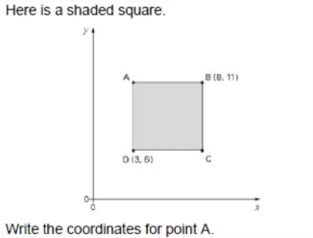  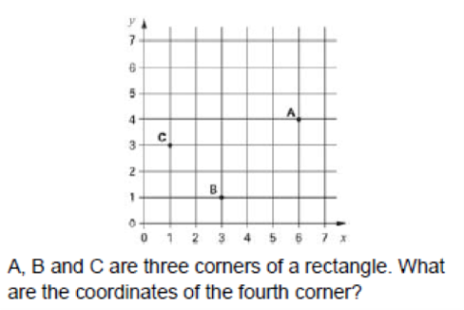
4 | Statistics | interpret and present discrete and continuous data using appropriate graphical methods, including bar charts and time graphs.  solve comparison, sum and difference problems using information presented in bar charts, pictograms, tables and other graphs. | What vehicles are very likely to pass the school gate between 10am and 11am? Why? Which vehicles will definitely not pass by? Why not? What vehicles would be possible but not very likely? Why?
5 | Number and place value | read, write, order and compare numbers to at least 1 000 000 and determine the value of each digit  count forwards or backwards in steps of powers of 10 for any given number up to 1 000 000  interpret negative numbers in context, count forwards and backwards with positive and negative whole numbers, including through zero  round any number up to 1 000 000 to the nearest 10, 100, 1000, 10 000 and 100 000  solve number problems and practical problems that involve all of the above  read Roman numerals to 1000 (M) and recognise years written in Roman numerals. | What is the value of the 7 in 3,274,106?  Write the next number in the counting sequence: 110,000, 120,000, 130,000  Here is part of a number sequence: 30, 70, 110, __, 190, __ How can you find the missing numbers?  What is 4773 rounded to the nearest hundred?  Find the missing number in 17.82 - __ = 17.22  Recognise Roman numerals in their historic context  Read and write Roman numerals to 1000
5 | Addition and subtraction | add and subtract whole numbers with more than 4 digits, including using formal written methods (columnar addition and subtraction)  add and subtract numbers mentally with increasingly large numbers  use rounding to check answers to calculations and determine, in the context of a problem, levels of accuracy  solve addition and subtraction multi-step problems in contexts, deciding which operations and methods to use and why. | 6432 + ___ = 8025  Find all the different totals that can be made using any 3 of these 5 numbers: 14,721, 76, 9534, 788, 6  Derive quickly related facts,  e.g. 80 + 50 = 130, 130 – 50 = 80, 800 + 500 = 1300, 1300 – 800 = 500  Children should be able to use rounding to approximate and check e.g. 2593 + 6278 must be more than 2500 + 6200, 2403 – 1998 is about 2400 – 2000  13,502 people were at the match last week and there are 2483 more this week, how many more people need to attend to bring the total to the club’s target of 20,000 people?
5 | Multiplication and division | identify multiples and factors, including finding all factor pairs of a number, and common factors of 2 numbers  know and use the vocabulary of prime numbers, prime factors and composite (non-prime) numbers  establish whether a number up to 100 is prime and recall prime numbers up to 19  multiply numbers up to 4 digits by a one- or two-digit number using a formal written method, including long multiplication for two-digit numbers  multiply and divide numbers mentally, drawing upon known facts  divide numbers up to 4 digits by a one-digit number using the formal written method of short division and interpret remainders appropriately for the context  multiply and divide whole numbers and those involving decimals by 10, 100 and 1,000  recognise and use square numbers and cube numbers, and the notation for squared (²) and cubed (³)  solve problems involving multiplication and division, including using their knowledge of factors and multiples, squares and cubes  solve problems involving addition, subtraction, multiplication and division and a combination of these, including understanding the meaning of the equals sign  solve problems involving multiplication and division, including scaling by simple fractions and problems involving simple rates | See calculation policy  Find some numbers that have a factor of 4 and a factor of 5. What do you notice?  My age is a multiple of 8. Next year my age will be a multiple of 7. How old am I?  See calculation policy  See calculation policy  The product is 400. At least one of the numbers is a multiple of 10. What 2 numbers could have been multiplied together? Are there any other possibilities?  Tell me how to work out the area of a piece of cardboard with dimensions 30cm by 30cm  Find two square numbers that total 45  Two numbers have a total of 1000 and a difference of 246. What are the two numbers?
5 | Fractions | compare and order fractions whose denominators are all multiples of the same number  identify, name and write equivalent fractions of a given fraction, represented visually,including tenths and hundredths  recognise mixed numbers and improper fractions and convert from one form to the other and write mathematical statements >1 as a mixed number[for example,²⁄₅+⁴⁄₅=⁶⁄₅= 1¹⁄₅]  add and subtract fractions with the same denominator and denominators that are multiples of the same number  multiply proper fractions and mixed numbers by whole numbers, supported by materials and diagrams  read and write decimal numbers as fractions [for example, 0.71 =⁷¹⁄₁₀₀]  recognise and use thousandths and relate them to tenths, hundredths and decimal equivalents  round decimals with two decimal places to the nearest whole number and to one decimal place  read, write, order and compare numbers with up to three decimal places  solve problems involving number up to three decimal places  recognise the per cent symbol (%) and understand that per cent relates to ‘number of parts per hundred’, and write percentages as a fraction with denominator 100, and as a decimal  solve problems which require knowing percentage and decimal equivalents of ¹⁄₂, ¹⁄₄,¹⁄₅, ²⁄₅ and those fractions with a denominator of a multiple of 10 or 25. | Children should be able to circle the two fractions that have the same value, or choose which one is the odd one out and justify their decision.  ⁶⁄₁₀, ³⁄₅, ¹⁸⁄₂₀,⁹⁄₁₅  Put the correct symbol, < or >, in each box.  3.03 ☐ 3.3  0.37 ☐ 0.327  Order these numbers: 0.27 0.207 0.027 2.07 2.7  How many halves in: 1 ½ 3 ½ 9 ½ …?  How many quarters in 1 ¼ 2 ¼ 5 ¼ ….?  What is ³⁄₁₀ of: 50, 20, 100…?  What is ⅘ of 50, 35, 100….?  What decimal is equal to 25 hundredths?  Write the total as a decimal:  4 + ⁶⁄₁₀ + ²⁄₁₀₀ =  Recognise that  0.007 is equivalent to ⁷⁄₁₀₀₀  6.305 is equivalent to ⁶³⁰⁵⁄₁₀₀₀  Write these numbers in order of size, starting with the smallest. 1.01, 1.001, 1.101, 0.11  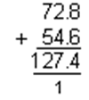  Write in the missing numbers. 30% of 60 is ☐  30% of ☐ is 60
5 | Measure | convert between different units of metric measure (for example, kilometre and metre; centimetre and metre; centimetre and millimetre; gram and kilogram; litre and millilitre)  understand and use approximate equivalences between metric units and common imperial units such as inches, pounds and pints  measure and calculate the perimeter of composite rectilinear shapes in centimetres and metres  calculate and compare the area of rectangles (including squares), and including using standard units, square centimetres (cm²) and square metres (m²) and estimate the area of irregular shapes  estimate volume [for example, using 1 cm³ blocks to build cuboids (including cubes)] and capacity [for example, using water]  solve problems involving converting between units of time  use all four operations to solve problems involving measure [for example, length, mass, volume, money] using decimal notation, including scaling. | What is two hundred and seventy six centimetres to the nearest metre?  How many millimetres are in 3 centimetres?  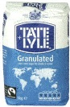  This bag of sugar weighs 1kg. Approximately how many pounds (lb) of sugar would fit into another empty bag of the same size as this one? Tick the correct answer.  20lb  14lb  2lb  4lb  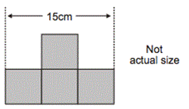  Which has the greatest area – a square with sides 6 cm long or a rectangle which is 7 cm long by 5 cm? How much greater is the area?
5 | Geometry- properties of shape | identify 3-D shapes, including cubes and other cuboids, from 2-D representations  know angles are measured in degrees: estimate and compare acute, obtuse and reflex angles  draw given angles, and measure them in degrees (°)  identify:  angles at a point and one whole turn (total 360°)  angles at a point on a straight line and ½ a turn (total 180°)  other multiples of 90°  use the properties of rectangles to deduce related facts and find missing lengths and angles  distinguish between regular and irregular polygons based on reasoning about equal sides and angles. | 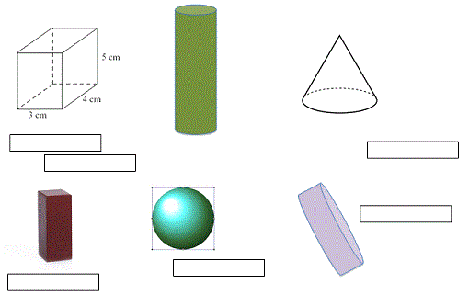Name these 3D shapes  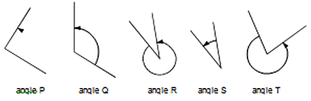  Label each angles, acute, obtuse or reflex. Put the 5 angles in size order.  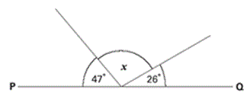  PQ is a straight line. Not drawn accurately.  Calculate the size of angle x  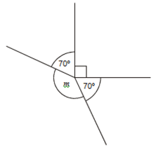  Calculate the size of angle m
5 | Geometry- position and direction | identify, describe and represent the position of a shape following a reflection or translation, using the appropriate language, and know that the shape has not changed. | 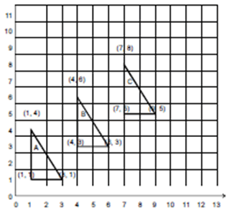  Write the co-ordinates of the next triangle in the sequence
5 | Statistics | solve comparison, sum and difference problems using information presented in a line graph  complete, read and interpret information in tables, including timetables. | The table shows the cost of coach tickets to different cities.  What is the total cost for a return journey to York for one adult and two children?  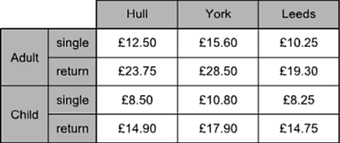
6 | Number and place value | read, write, order and compare numbers up to 10 000 000 and determine the value of each digit  round any whole number to a required degree of accuracy  use negative numbers in context, and calculate intervals across zero  solve number problems and practical problems that involve all of the above. | 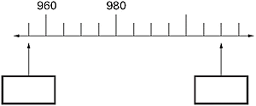  Fill in the missing numbers on this number line  Children should be able to circle the best estimate of the answer to questions such as;  72.34 ÷ 8.91  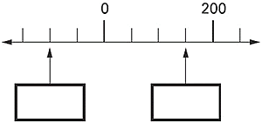  Fill in the missing numbers on this number line  The temperature inside an aeroplane is 20°C The temperatures outside the aeroplane is -30°C. What is the difference between these temperatures?
6 | 4 operations | multiply multi-digit numbers up to 4 digits by a two-digit whole number using the formal written method of long multiplication  divide numbers up to 4 digits by a two-digit whole number using the formal written method of long division, and interpret remainders as whole number remainders, fractions, or by rounding, as appropriate for the context  divide numbers up to 4 digits by a two-digit number using the formal written method of short division where appropriate, interpreting remainders according to the context  perform mental calculations, including with mixed operations and large numbers  identify common factors, common multiples and prime numbers  use their knowledge of the order of operations to carry out calculations involving the four operations  solve addition and subtraction multi-step problems in contexts, deciding which operations and methods to use and why  solve problems involving addition, subtraction, multiplication and division  use estimation to check answers to calculations and determine, in the context of a problem, an appropriate degree of accuracy. | Printing charges for a book are 3p per page and 75p for the cover. I paid £4.35 to get this book printed. How many pages are there in the book? Write down the calculations that you did.  Every day a machine makes 100 000 paper clips, which go into boxes. A full box has 120 paper clips. How many full boxes can be made from 100 000 paper clips?  Start from a two-digit number with at least six factors, e.g. 72. How many different multiplication and division facts can you make using what you know about 72? What facts involving decimals can you derive?  Two numbers have a difference of 1.583. One of the numbers is 4.728. What is the other? Is this the only answer?  Peter has £10. He buys 3 kg of potatoes at 87p per kg and 750 g of tomatoes at £1.32 per kg. How much money does he have left?
6 | Fractions | use common factors to simplify fractions; use common multiples to express fractions in the same denomination  compare and order fractions, including fractions >1  add and subtract fractions with different denominators and mixed numbers, using the concept of equivalent fractions  multiply simple pairs of proper fractions, writing the answer in its simplest form [for example, ¼ × ½ = ¹⁄₈]  divide proper fractions by whole numbers [for example, ¹⁄₃ ÷ 2 = ¹⁄₆]  associate a fraction with division and calculate decimal fraction equivalents [for example, 0.375] for a simple fraction [for example, ³⁄₈]  identify the value of each digit in numbers given to three decimal places and multiply and divide numbers by 10, 100 and 1000 giving answers up to three decimal places  multiply one-digit numbers with up to two decimal places by whole numbers  use written division methods in cases where the answer has up to two decimal places.  solve problems which require answers to be rounded to specified degrees of accuracy  recall and use equivalences between simple fractions, decimals and percentages including in different contexts. | Children should be able to recognise that a fraction such as ⁵⁄₂₀ can be reduced to an equivalent fraction of ¼ by dividing both numerator and denominator by the same number  What number is half way between 5 ¼ and 5 ½ ?  Joe has some pocket money. He spends three-quarters of it. He has fifty pence left. How much pocket money did he have?  Recognise that ¼ of 12, ¼ x 12 and 12 divided by 4 are equivalent  Children should be able to:  Decide whether they would prefer to share ½ of a pizza with 2 people or ¾ of a pizza with 4 people and explain why.  What is 3.86 multiplied by nine?  Four friends win £48,623. The money is to be shared equally between them – how much will each person receive?
 | Ratio, proportion, algebra | solve problems involving the relative sizes of two quantities where missing values can be found by using integer multiplication and division facts  solve problems involving the calculation of percentages [for example, of measures, and such as 15% of 360] and use percentages for comparison  solve problems involving similar shapes where the scale factor is known or can be found  solve problems involving unequal sharing and grouping using knowledge of fractions and multiples  use simple formulae  generate and describe linear number sequences  express missing number problems algebraically  find pairs of numbers that satisfy number sentences involving two unknowns  enumerate possibilities of combinations of two variables | A recipe for 3 portions requires 150 g flour and 120 g sugar. Desi’s solution to a problem says that for 2 portions he needs 80 g flour and 100 g sugar. What might Desi have done wrong? Work out the correct answer.  25% of the apples in a basket are red. The rest are green. There are 21 red apples. How many green apples are there?  Two letters have a total weight of 120 grams. One letter weighs twice as much as the other. Write the weight of the heavier letter.  What fraction is 18 of 12  Here are five number cards:  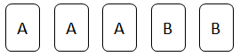  A and B stand for two different whole numbers.  The sum of all the numbers on all five cards is 30.  What could be the values of A and B?
 | Measure | solve problems involving the calculation and conversion of units of measure, using decimal notation up to three decimal places where appropriate  use, read, write and convert between standard units, converting measurements of length, mass, volume and time from a smaller unit of measure to a larger unit, and vice versa, using decimal notation to up to three decimal places  convert between miles and kilometres  recognise that shapes with the same areas can have different perimeters and vice versa  recognise when it is possible to use the formulae for area and volume of shapes  calculate the area of parallelograms and triangles  calculate, estimate and compare volume of cubes and cuboids using standard units, including cubic centimetres (cm³) and cubic metres (m³), and extending to other units [for example, mm³ and km³] | They should be able to answer questions such as: approximately how many litres are there in 3 gallons? Give your answer to the nearest litre.  Estimate the difference in centimetres between 50 cm and 1 foot.  Pupils should know the approximate equivalence between commonly used imperial units and metric units:  e.g. 1 litre is approximately 2 pints (more accurately, 1 ¾ pints)  4.5 litres is approximately 1 gallon or 8 pints  1 kilogram is approximately 2 lb (more accurately, 2.2 lb)  30 grams is approximately 1 oz  8 kilometres is approximately 5 miles  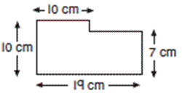  Children should be able to calculate the perimeters of compound shapes that can be split into rectangles. For example,
 | Geometry-properties of shape | draw 2-D shapes using given dimensions and angles  recognise, describe and build simple 3-D shapes including making nets  compare and classify geometric shapes based on their properties and sizes and find unknown angles in any triangles, quadrilaterals, and regular polygons  illustrate and name parts of circle, including radius, diameter and circumference and know that the diameter is twice the radius  recognise angles where they meet at a point, are on a straight line, or are vertically opposite, and find missing angles. | ‘I am thinking of a 3D shape. It has a square base. It has four other faces which are triangles. What is the name of the 3D shape?’  ‘Give me instructions to get me to draw a rhombus using my ruler and a protractor’  They should know that:  - The circumference is the distance round the circle  - The radius is the distance from the centre to the circumference  - The diameter is 2 x radius  ‘There are nine equal angles around a point. What is the size of each angle?’
 | Geometry- position and direction | describe positions on the full coordinate grid (all four quadrants)  draw and translate simple shapes on the coordinate plane, and reflect them in the axes. | 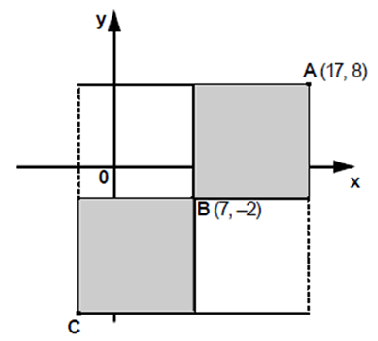  A is the point (17,8). B is the point (7,-2).  What are the co-ordinates of the point C?
 | Statistics | interpret and construct pie charts and line graphs and use these to solve problems  calculate and interpret the mean as an average | This graph shows the number of people living in a town.  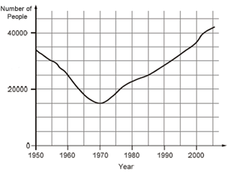  How many people lived in the town in 1985?  In which year was the number of people the same as in 1950?  Find the year when the number of people first went below 20 000.

