In Harmony – an explanation by Marcus
In Harmony, is a fun lesson where you learn different instruments and learn different pieces of music. You have three choices violin, viola or cello as you go up through primary you have different grades 1, 2 and 3. Here is a website for you to learn your pieces www.nottinghammusichub.co.uk. Find resources and click in harmony there you should find on the side a list of instruments find your instrument and click it to bring up your songs.

It’s a 45 minute session so make the most of it and have fun you will only have 2 sessions a week so you will have 90 minutes a week.
On Monday and Tuesday Ellie and Helen are the In Harmony teachers on Friday for yr6 there teachers are Ellie and Matt.
http://www.nottinghammusichub.org.uk/resources/grade-exams/cello
http://www.nottinghammusichub.org.uk/resources/grade-exams/viola
http://www.nottinghammusichub.org.uk/resources/grade-exams/violin
On a Tuesday after school there is an opportunity for you to learn extra music, the band is called North Area Band in the upper hall 3:30p – 5:00pm. Also if you go to area band then there is a teacher called Graham he runs Nottingham Music School on a Saturday. There are different teachers for you to meet at area band and Nottingham music school. If you wanted when you leave primary you get to take your instrument through secondary school. Here is a web site for Saturday music school http://www.nottinghammusichub.org.uk/resources/intermediate-orchestra
So go ahead and check it out don’t be frightened to try it out
If you don’t enjoy it you don’t have to go every Saturday
Same with area band also area band isn’t just for primary it’s for secondary and is joined by other schools playing different instruments like flutes trombones baritone’s guitars etc.
7th December: Christmas in the City concert at Nottingham Albert Hall was an event that some year 5s went to including me and I played with Nottingham music school and so did my brother.
There are lots of different events to go to if you join area band and Nottingham music school like the one I listed above.
http://www.nottinghammusichub.org.uk/adImages/img_0082_142x92.jpg
Some of the other teachers of In Harmony are Rachael who plays the clarinet, Graham plays violin and viola, Hannah plays the trumpet. Matt plays viola and drums.
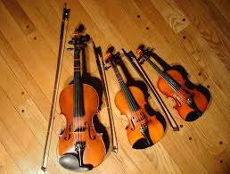 There are 3 different sized violins.

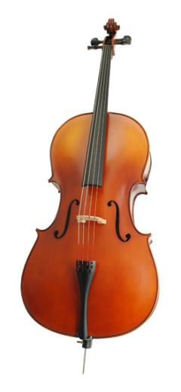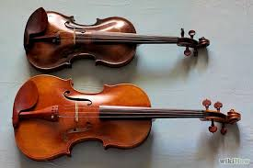There are 2 different sized violas

