Monday 24th February 2025

The Bee Musical – 2nd and 3rd April
Dear Parent/carer,
I am pleased to let you know that tickets are now available for this year’s Lower Key Stage 2 production of The Bee Musical, which will be performed twice, on:
- Wednesday 2nd April at 9:15am, and
- Thursday 3rd at 2:15pm
The children have been practising hard and are very excited to share this production with you. We would be very grateful if you could support your children at home in learning any lines that have been assigned to them. They also need to practise projecting their voices – (maybe you could listen from a different room!).
We look forward to welcoming you.
Yours faithfully,
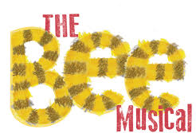
Year 3 / 4 team

