YEAR 6 Residential- Kingswood
Dear Parents/Carers,
Every year at Robin Hood we book in a residential trip for all children in Year 6 to go on residential. The location is at the Kingswood, Dearne Valley in Doncaster. This year the trip will be on Wednesday 2nd -Friday 4th October 2024. Going on a residential is brilliant for building self-confidence and independence. We would love every child in our current Y5 cohert to attend this trip. We need to confirm numbers with Kingswood by end of January so we are asking parents to reserve their child’s spot via Arbor by January 24th 2025. After this time we will NOT be able to guarantee your child a place on the residential for when they are in Y6.

Date of trip | Wednesday 1st October- Friday 3rd October 2025
Travel times | The coach will leave school in the Wednesday 1st October at lunchtime and the return will be during the afternoon of Friday 3rd October. More precise times will come out to you closer to the departure date.
What to wear | Children will need to wear clothing suitable for outdoor activities as well as packing a bag which contains spare clothes for the trip. A kit list will be sent out prior to the trip.
Spending money | Your child will NOT need any spending money.
Lunch | Children need a packed lunch for Wednesday 1st October, you can either bring your own or the school can provide a Grab Bag. We will send a link to order grab bags closer to the time.  All other meals are provided throughout the trip.
Cost | £205 (Children in receipt of Pupil Premium = £153.75)

As this trip is paid for via Arbor we will take this payment as consent for your child to go on the trip. Payment can be made in instalments on Arbor. Medical forms will be completed prior to the trip.
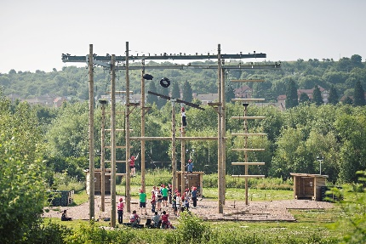

Kind Regards,
The Y6 Team

